**Software:**

Software is a set of instructions, data or programs used to operate computers and execute specific tasks

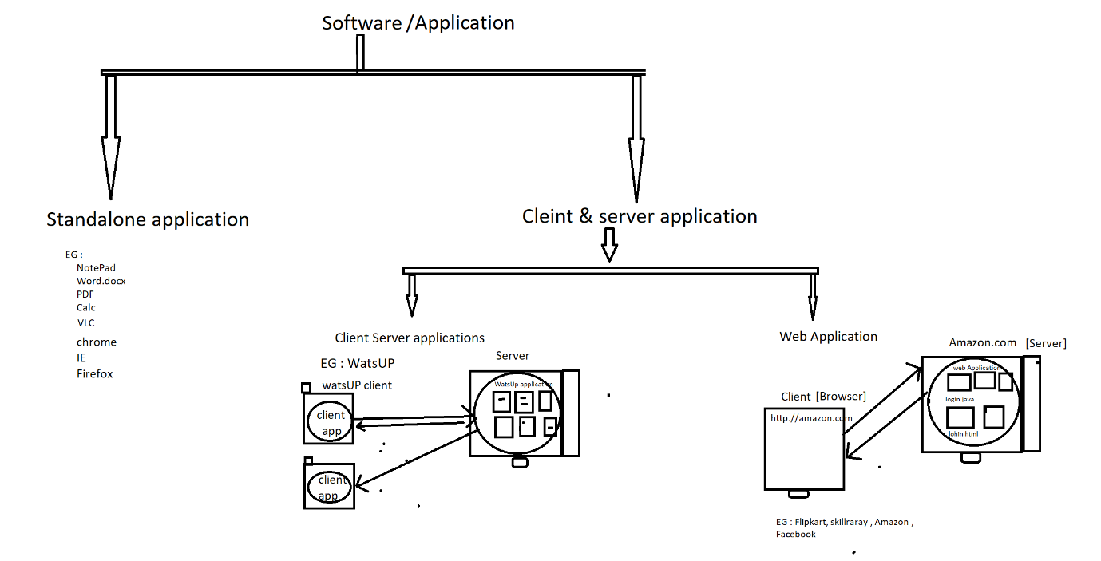

**Standalone application:**

The Application which is installed in computer, where those application can be accessed by one user at a time is called Standalone software.

EG :

Calc

Word

Excel

NotePad

**Client server application:**

client/server application consists of a client program that consumes services provided by a server program. The client requests services from the server by calling functions in the server application

🡺Pure client server application is always accessed via client software

EG :

WhatsApp

Skype

GoToMeeting

**Web Application :**

The application which is accessed via browser & URL is called web application &

Browser is one and only way to access any web application

**🡺**Pure web application is always accessed via URL

EG :

FaceBook

Amazon

Flipkart

Irctc.com

makeMytrip